Using Android Service (Streaming Music)

A **Service** is an application component that can perform long-running operations in the background, and it doesn't provide a user interface.

For the images:

1. Download a play image and stop image then put it into drawable.
2. Create a Main Activity and design the activity_main.xml (xml file) like this.

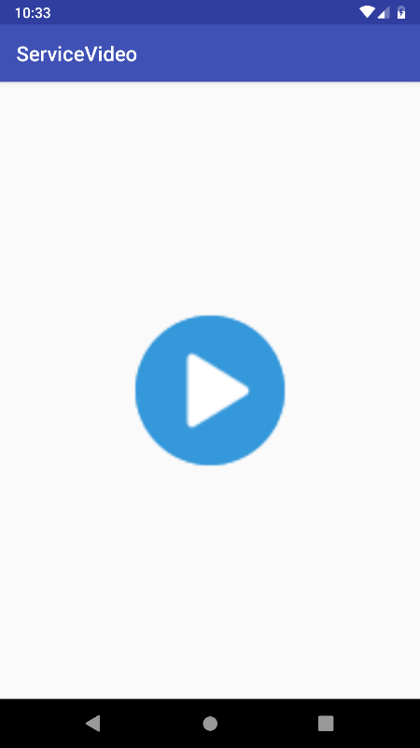

**MainActivity.java**

import android.content.Context;  
import android.content.Intent;  
import android.media.Image;  
import android.support.v7.app.AppCompatActivity;  
import android.os.Bundle;  
import android.view.View;  
import android.widget.ImageView;  
import android.widget.Toast;  
  
public class MainActivity extends AppCompatActivity implements MusicStoppedListener{  
  
 ImageView ivPlayStop;  
 String audioLink = "https://dl.dropbox.com/s/5ey5xwb7a5ylqps/game_of_thrones.mp3?dl=0";  
 boolean musicPlaying = false;  
 Intent serviceIntent;  
  
 @Override  
 protected void onCreate(Bundle savedInstanceState) {  
 super.onCreate(savedInstanceState);  
 setContentView(R.layout.*activity_main*);  
  
 ivPlayStop = (ImageView) findViewById(R.id.*ivPlayStop*);  
 ivPlayStop.setBackgroundResource(R.drawable.*play*);  
 serviceIntent = new Intent(this, MyPlayService.class);  
  
 ApplicationClass.*context* = (Context) MainActivity.this;  
  
 ivPlayStop.setOnClickListener(new View.OnClickListener() {  
 @Override  
 public void onClick(View v) {  
  
 if(!musicPlaying){  
 playAudio();  
 ivPlayStop.setImageResource(R.drawable.*stop*);  
 musicPlaying = true;  
 }else{  
 stopPlayService();  
 ivPlayStop.setImageResource(R.drawable.*play*);  
 musicPlaying = false;  
 }  
  
 }  
 });  
 }  
  
 private void stopPlayService() {  
  
 try{  
 stopService(serviceIntent);  
 }catch(SecurityException e){  
 Toast.*makeText*(this, "Error: " + e.getMessage(), Toast.*LENGTH_SHORT*).show();  
 }  
  
 }  
  
 private void playAudio() {  
  
 serviceIntent.putExtra("audioLink", audioLink);  
  
 try{  
 startService(serviceIntent);  
 }catch(SecurityException e){  
 Toast.*makeText*(this, "Error: " + e.getMessage(), Toast.*LENGTH_SHORT*).show();  
 }  
  
 }  
  
 @Override  
 public void onMusicStopped() {  
 ivPlayStop.setImageResource(R.drawable.*play*);  
 musicPlaying = false;  
 }  
}

**activity_main.xml**

<?xml version="1.0" encoding="utf-8"?>  
<android.support.constraint.ConstraintLayout xmlns:android="http://schemas.android.com/apk/res/android"  
 xmlns:app="http://schemas.android.com/apk/res-auto"  
 xmlns:tools="http://schemas.android.com/tools"  
 android:layout_width="match_parent"  
 android:layout_height="match_parent"  
 tools:context=".MainActivity">  
  
 <ImageView  
 android:id="@+id/ivPlayStop"  
 android:layout_width="150dp"  
 android:layout_height="150dp"  
 android:clickable="true"  
 app:layout_constraintBottom_toBottomOf="parent"  
 app:layout_constraintEnd_toEndOf="parent"  
 app:layout_constraintStart_toStartOf="parent"  
 app:layout_constraintTop_toTopOf="parent"  
 app:srcCompat="@drawable/play" />  
</android.support.constraint.ConstraintLayout>

1. In the AndroidManifest.xml add these line

<uses-permission android:name="android.permission.INTERNET" />

Between the package and application

1. In the java package on the first folder create a new Service and Choose the Service and rename it as “MyPlayService” and then uncheck the exported but the imported is left checked.

**MyPlayService.java**

import android.app.Service;  
import android.content.Context;  
import android.content.Intent;  
import android.media.MediaPlayer;  
import android.os.IBinder;  
import android.widget.Toast;  
  
public class MyPlayService extends Service implements MediaPlayer.OnCompletionListener,  
 MediaPlayer.OnPreparedListener, MediaPlayer.OnErrorListener,  
 MediaPlayer.OnSeekCompleteListener, MediaPlayer.OnInfoListener,  
 MediaPlayer.OnBufferingUpdateListener{  
  
 private MediaPlayer mediaPlayer;  
 String link;  
 private MusicStoppedListener musicStoppedListener;  
  
 public MyPlayService() {  
 }  
  
 @Override  
 public IBinder onBind(Intent intent) {  
 // *TODO: Return the communication channel to the service.* throw new UnsupportedOperationException("Not yet implemented");  
 }  
  
 @Override  
 public void onCreate() {  
 super.onCreate();  
  
 //connection to media player  
 mediaPlayer = new MediaPlayer();  
  
 //set click listener on media player  
 mediaPlayer.setOnCompletionListener(this);  
 mediaPlayer.setOnPreparedListener(this);  
 mediaPlayer.setOnErrorListener(this);  
 mediaPlayer.setOnSeekCompleteListener(this);  
 mediaPlayer.setOnInfoListener(this);  
 mediaPlayer.setOnBufferingUpdateListener(this);  
 }  
  
 @Override  
 public int onStartCommand(Intent intent, int flags, int startId) {  
  
 link = intent.getStringExtra("audioLink");  
 mediaPlayer.reset();  
 musicStoppedListener = (MusicStoppedListener) ApplicationClass.*context*;  
  
 if(!mediaPlayer.isPlaying()){  
 try{  
 mediaPlayer.setDataSource(link);  
 mediaPlayer.prepareAsync();  
 }catch(Exception e){  
 Toast.*makeText*(this,"Error: " + e.getMessage(), Toast.*LENGTH_SHORT*).show();  
 }  
 }  
 return *START_STICKY*;  
 }  
  
 @Override  
 public void onDestroy() {  
 super.onDestroy();  
  
 if(mediaPlayer != null){  
 if(mediaPlayer.isPlaying()){  
 mediaPlayer.stop();  
 }  
  
 mediaPlayer.release();  
 }  
 }  
  
 @Override  
 public void onBufferingUpdate(MediaPlayer mp, int percent) {  
  
 }  
  
 @Override  
 public void onCompletion(MediaPlayer mp) {  
  
 if(mp.isPlaying()){  
 mp.stop();  
 }  
  
 musicStoppedListener.onMusicStopped();  
 stopSelf();  
  
 }  
  
 @Override  
 public boolean onError(MediaPlayer mp, int what, int extra) {  
  
 switch (what){  
 case MediaPlayer.*MEDIA_ERROR_NOT_VALID_FOR_PROGRESSIVE_PLAYBACK*:  
 Toast.*makeText*(this, "MEDIA_ERROR_NOT_VALID_FOR_PROGRESSIVE_PLAYBACK",  
 Toast.*LENGTH_SHORT*).show();  
 break;  
  
 case MediaPlayer.*MEDIA_ERROR_SERVER_DIED*:  
 Toast.*makeText*(this, "MEDIA_ERROR_SERVER_DIED",  
 Toast.*LENGTH_SHORT*).show();  
 break;  
  
 case MediaPlayer.*MEDIA_ERROR_UNKNOWN*:  
 Toast.*makeText*(this, "MEDIA_ERROR_UNKNOWN",  
 Toast.*LENGTH_SHORT*).show();  
 break;  
 }  
  
 return false;  
 }  
  
 @Override  
 public boolean onInfo(MediaPlayer mp, int what, int extra) {  
 return false;  
 }  
  
 @Override  
 public void onPrepared(MediaPlayer mp) {  
  
 if(!mp.isPlaying()){  
 mp.start();  
 }  
  
 }  
  
 @Override  
 public void onSeekComplete(MediaPlayer mp) {  
  
 }  
}

1. In the java package on the first folder create again a new class and rename it as “MusicStoppedListener”, change its kind into “Interface”

**MusicStoppedListener.java (Interface)**

public interface MusicStoppedListener {  
  
 void onMusicStopped();  
  
}

1. In the java package on the first folder create again a new java class and rename it as “ApplicationClass”

**ApplicationClass.java**

import android.app.Application;  
import android.content.Context;  
  
public class ApplicationClass extends Application{  
  
 public static Context *context*;  
  
 @Override  
 public void onCreate() {  
 super.onCreate();  
 }  
}